Department for Education coronavirus helpline

The Department for Education coronavirus helpline is available to answer questions about COVID-19 relating to education and children’s social care. Staff, parents and young people can contact this helpline as follows:

Phone: 0800 046 8687
Opening hours: 8am to 6pm (Monday to Friday), 10am to 4pm (Saturday to Sunday)
To help parents, carers, professionals and partners stay informed over the coming weeks, this newsletter will now be going out on a weekly basis. If anyone you know would like to subscribe to the newsletter, they can sign up here.

Coronavirus symptoms? Follow the national NHS advice here.
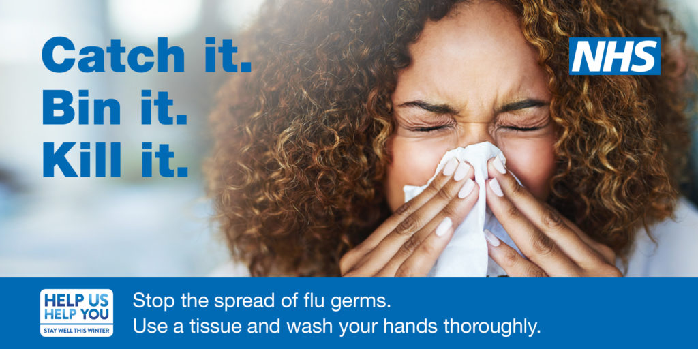

Updates on coronavirus
View the latest guidance on coronavirus, including information for:
Care Providers
Businesses
Communities
More local and national guidance on coronavirus.
The importance of washing hands
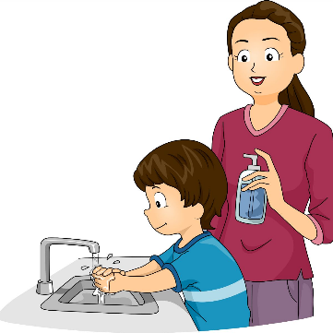
A simple trick using pepper, soap and water is being used to teach children about the importance of washing their hands amid the Coronavirus pandemic.
Watch the video >
The national advice is to wash your hands with soap and warm water for at least 20 seconds.

