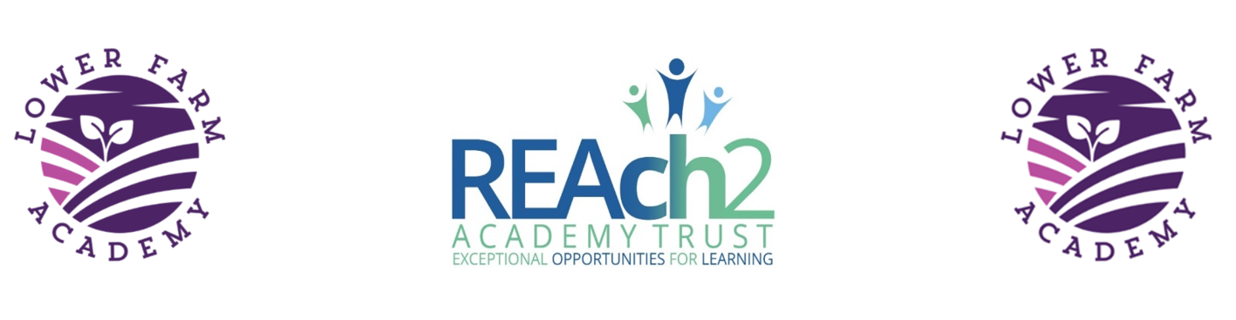
Lower Farm Academy
Lunchtime Supervisor Advert

Post: Lunchtime Supervisor starting September 2020

Location: Lower Farm Academy, Milking Lane, Nuneaton, CV10 0FG

Employer: Reach2 Academy Trust

Terms: 7.5 hours per week until October half term then there is possibility of increasing to 8.75 hours per week/ Term Time only - Permanent

Salary: SCP 1-3 £9.00ph RLW £17364 per annum per annum pro- rata. Actual Salary £3001.05

About the Role:

Lower Farm Academy is brand new school opening in September. We are looking to appoint a caring and dynamic lunchtime supervisor who will be responsible for collection of lunches from the local high school so transport essential, overseeing children throughout the lunchtime period. You will assist with pupils’ table manners and use of cutlery and will also be responsible for coordinating a range of interactive play activities, administering minor first aid and ensuring the welfare and safety of the pupils.

This is an exciting opportunity; we look forward to receiving your application.

Closing Date: Thursday 27th August 2020 12 noon

Interview Date: Friday 28th August 2020

Application Form:
Please return your completed application form to:
Cherie Padmore, School Business Manager, Lower Farm Academy, Milking Lane, Nuneaton, CV10 0FG
or email sbm@lowerfarmacademy.org

Application Documents:
Application form
Job Description
Monitoring form

Additional Information
Lower Farm Academy is committed to safeguarding and promoting the welfare of children and young people/vulnerable adults and expects all staff and volunteers to share this commitment.

This position is subject to an enhanced DBS Check and satisfactory written references.

If you are interested in more information on REAch2, please visit our Reach2 vacancies page: http://reach2.org/vacancies/

