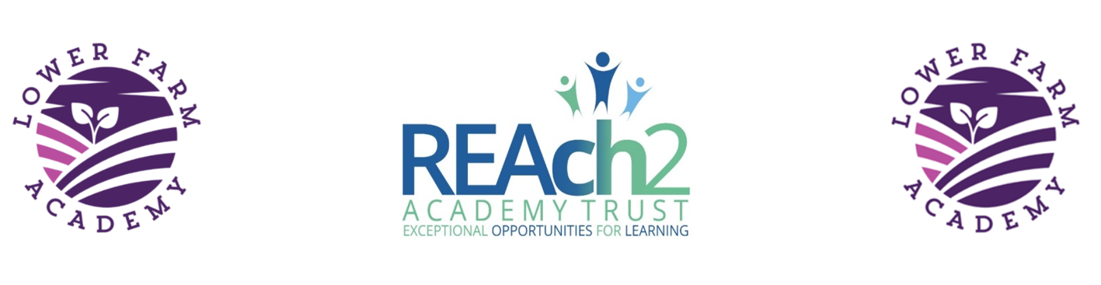
Lower Farm Academy

Cleaner Job Advert

Post: Cleaner, starting September 2020

Location: Lower Farm Academy, Milking Lane, Nuneaton, CV10 0FG

Employer: Reach2 Academy Trust

Hours: Part Time, 5 hours per week. Term Time plus agreed holiday hours.

Salary: SCP 1-3 £9.00ph RLW £17364 per annum per annum pro- rata. Actual Salary £2000.67

About The Role:

Lower Farm Academy is brand new school opening in September. We are looking for a pro-active, dedicated cleaner to join our team. Initially a 12-month contract, there will be opportunities for the right candidate beyond this as the school moves from its temporary site into our permanent building in September 2021.

The successful candidate will:

- Ideally have previous experience in a school environment, although this is not essential.
- be enthusiastic, highly motivated, enjoy working with young children and be passionate about making a positive difference to children’s lives.
- be able to work as part of a successful, hardworking, dedicated team

If you feel that you would like to be part of a growing school in Nuneaton that is committed to excellence, we would like to hear from you.

Application packs are available from the school office or online. If you require any further information, please contact the School Business Manager by email at sbm@lowerfarmacademy.org

Closing date: Tuesday 25th August 2020
Interview Date: Thursday 27th August 2020

Application Form: Please return your completed application form to Cherie Padmore, School Business Manager, Lower Farm Academy, Milking Lane, Nuneaton, CV10 0FG or email sbm@lowerfarmacademy.org

Additional Information

Lower Farm Academy is committed to safeguarding and promoting the welfare of children and young people/vulnerable adults and expects all staff and volunteers to share this commitment.
This position is subject to an enhanced DBS Check and satisfactory written references.

Application Documents:
Application form
Job description
Equal Opportunities Monitoring Form

