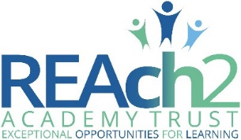

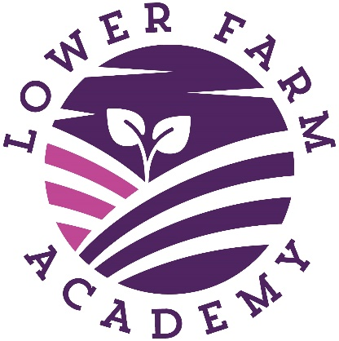

Equality Statement
2022-25

Audience: | Parents  School staff  Local Governing Body  Trustees
Ratified: | Local Governing Board  September 2022
Other related policies: | SEND Policy
Policy owner: | Mr How
Review frequency: | 3 years

Signed by:
Headteacher Date:
Governor Date:

Equality Statement

Lower Farm Academy is committed to the principle of equal opportunities for all. We operate an inclusive curriculum, which respects the diverse needs of every child.

This statement demonstrates our commitment to ensure full access to the progression through the curriculum for all pupils. In addition, it acts as a positive focus when considering matters of school management and organisation.

We encourage the development and promotion of positive attitudes through the implementation of a curriculum which is broad and balanced, thus enabling all pupils regardless of colour, race, creed, gender or special educational needs, to have full access to the curriculum.

We believe that by acknowledging, valuing and understanding our similarities and differences that members of our society will play an active role in contributing to our future society. The academy’s touchstones, and in particular our positive behaviour expectations and learning powers are at the heart of all we do.

We recognise that prejudice can, and does, exist at all levels in our society. However, it will not be tolerated at any level within our academy.

We value all our children at Lower Farm Academy and recognise the positive contribution each child can make in enriching and enhancing the ethos of our academy and wider community.

This is an annual statement made on behalf of the Local Governing Body by the Headteacher.

Andy How
Head teacher

- Our equality vision and values that underpin school life

Vision

We serve our community by providing an education of the highest quality, with exceptional experiences for every pupil, every day. This will be achieved by providing an exciting learning environment, which fosters a real love of learning and inspires all our pupils to become confident, caring and responsible individuals who exemplify our school values.

Values

Our school values will enable all children to flourish and reach their full potential within an inclusive, safe and stimulating setting:

Resilience – keep trying until you fulfil your hopes and aspirations.
Respect – showing acceptance, understanding and compassion.
Care – a commitment to helping others flourish.
Collaboration – working together in friendship and community.
Achievement – developing wisdom and talents in all areas of life.
Integrity – doing the right thing, showing good manners and morals.

Our children will be able to articulate, discuss and demonstrate these values and their meaning not only within the academy, but also as they continue their journey and learn to make a positive contribution to society.

Fundamental British Values

As part of the value system, the academy actively promotes and encourages the fundamental British values which permeate through all aspects of school life, and link seamlessly with the six core values of Lower Farm. These are:

- Democracy
- The Rule of Law
- Individual Liberty
- Mutual Respect
- Tolerance of those of different faiths and beliefs

These values are regularly promoted through high quality teaching, a rounded programme of collective worship and assemblies and a positive behaviour policy. This provision allows pupils to develop and demonstrate skills and attitudes that will allow them to participate fully in and contribute positively to life in modern Britain. As well as teaching our pupils, our active promotion of these values also means we challenge pupils, staff or parents who express contrary opinions.

Academy aims

- Value and recognise the uniqueness and achievement of every member of our academy family
- Raise the aspirations of everyone within our academy community so everyone strives for personal excellence in everything they do
- Nurture and support all abilities, helping every child to achieve his/her potential in all areas of learning – intellectual, emotional, physical, social, moral, spiritual and cultural, placing children’s happiness at the core of what we do
- Provide outstanding teaching and learning which enables all students, regardless of gender, race, background or ability, to excel
- Equip children with the resilience and perseverance to become creative and independent thinkers and to become lifelong learners within an ever-changing world
- Provide a rich, broad and balanced curriculum with emphasis on English, Mathematics, Science and the Arts
- Develop learning activities which stimulate positive models of enquiry, reflection, challenge and innovation
- Promote British Values alongside our school values to embody attitudes of care, tolerance, honesty, trust and respect within the academy and wider communities so that children develop as well-rounded and responsible citizens for the future
- Develop outstanding relationships with ‘Parents as Partners’ of their children’s education and with all our stakeholders so everyone works together to achieve the best outcomes.

Key values upon which the academy is based

REAch2 Touchstones
Lower Farm Academy models itself on the touchstones of REAch2, whereby as a Trust and an individual academy, we are committed to creating a culture that strongly reflects our Touchstones, seven principles that makes our academy unique and sets us apart from others. Our touchstones are used to express the values and ethos of the Trust and of Lower Farm Academy, and describe what we will be known for and how we operate:

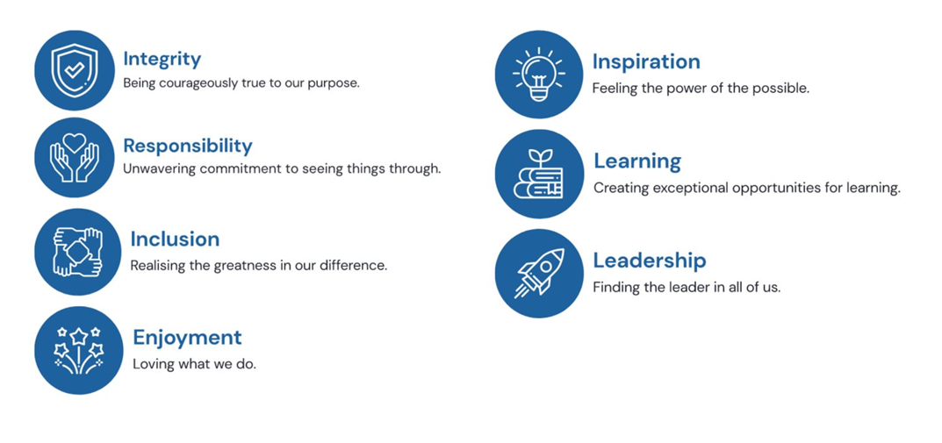

- The characteristics of our school

Lower Farm Academy will be a new school built on the outskirts of Nuneaton, a highly populated and expanding town in north east Warwickshire. Over the coming years, the council are hoping to create a vibrant and thriving town as part of an ongoing regeneration project, offering a wide range of shopping, leisure, entertainment and educational facilities. The academy will be part of this regeneration, situated on a growing housing development, a short walk away from two other housing developments that are well underway. Social housing will form part of the offering on these new developments. The academy is a two-form entry with a Nursery that is growing each year from the bottom up (currently Nursery to Year 3).

Lower Farm will be a school which is designed to meet and be responsive to the needs of the local community it serves. With three other primary schools close by, it is key that Lower Farm works collaboratively alongside them, but at the same time, remains distinctive.

Characteristic | Total | Breakdown (number and %)
Number of pupils | 150 | For the academic year 2022-23: (44 Reception, 34 x Year 1, 50 x Year 2 and 22 Year 3).
Number of staff | 20 | For the academic year 2022-23
Number of governors | 10 | 8 female (80%)  2 male (20%)
Religious character | Non-denominational
Attainment on entry | Just below
Stability of school population | 35 (23%) whole school | R – 0% mobility  Y1 - 14% mobility  Y2 – 41% mobility  Y3 – 50% mobility
Pupils eligible for FSM | 31 | 21%
Deprivation factor |  | Not yet known
Disabled staff | 0 | 0
Disabled pupils (SEN/LDD) | 0 | 0
Disabled pupils (no SEN) | 0 | 0
BAME pupils | 48 | 32%
BAME staff | 3
Pupils who speak English as an  additional language | 24 | 16%
Average attendance rate | 97.2% to date | 98.0% for 2019-20  96.4% For 2020-21  95.2% For 2021-22
Significant partnerships,  extended provision, etc. |  | REAch2 Academy Trust  Warwickshire County Council
Awards, accreditations,
specialist status

- Our duties

At Lower Farm Academy we welcome our duties under the Equality Act 2010.

The Governing Body of Lower Farm Academy is committed to promoting equality and diversity and eliminating discrimination, harassment, victimisation and any other conduct that is prohibited by or under the Equality Act 2010.

By recognising and appreciating individual needs and differences the school will be broadly representative of the communities it serves, and be a place where children and staff will thrive – physically, mentally, socially, and spiritually.

We aim to advance equality of opportunity, and foster good relations between persons who share a relevant protected characteristic and persons who do not share it. This will be achieved by implementing equal opportunities and diversity practice across the three dimensions of the School: as an employer; an educator; and a resource of the local community.

We will ensure that the whole school community is aware of the Equality & Diversity Statement and our published equality information and objectives, by informing parents that they are published on our website and in our school prospectus.

Lower Farm Academy is committed to meeting its public sector statutory duties as detailed below. We understand that the duties apply to service delivery and employment and staff management as well as policy development and implementation.

The purpose of this information is to set out how our practice and policies have due regard to the need to:

- eliminate discrimination, harassment, victimisation and any other conduct that is prohibited by or under this Act.
- advance equality of opportunity between persons who share a relevant protected characteristic and persons who do not share it
- foster good relations between persons who share a relevant protected characteristic and persons who do not share it.

- Protected characteristics

We understand the principle of the Act and the work needed to ensure that those with protected characteristics are not discriminated against and are given equality of opportunity. A protected characteristic under the act covers the groups listed below:

- disability (as defined by the equality Act 2010) and those who have additional educational needs
- groups of pupils whose prior attainment may be different from that of other groups
- those who are academically more able
- pupils for whom English is an additional language
- looked after children
- young carers
- ethnicity
- religion and belief
- pupils from low income backgrounds
- Gypsy, Roma and Traveller children
- gender
- gender reassignment
- sexual identity
- age (for employees)
- maternity and pregnancy (for employees)
- marriage and civil partnership (for employees)
- children from military families
- other vulnerable groups

- Disability

At Lower Farm Academy, we implement accessibility plans which are aimed at:

- increasing the extent to which disabled pupils can participate in the curriculum;
- improving the physical environment of schools to enable disabled pupils to take better advantage of education, benefits, facilities and services provided;
- improving the availability of accessible information to disabled pupils.

- How we meet our legal and general duties

In order to meet our general duties, listed above, the law requires us to do some specific duties to demonstrate how we meet the general duties. These are to:

Publish equality information
No information will be published which could specifically identify any individual child or adult.

Prepare and publish equality objectives
To do this we will collect data related to the protected characteristics above and analyse this data to determine our focus for our equality objectives. The data will be assessed across our core provisions as a school. This will include the following functions:
- Admissions
- Attendance
- Attainment
- Exclusions
- Prejudice related incidents

We will use the information collected to:
- evaluate how well we comply with all our duties under the Equality Act
- assess the potential and actual impact of policies and procedures
- decide where positive action may be appropriate
- identify priorities, set equality objectives and update our accessibility plan
- monitor progress towards meeting these objectives and implementing our accessibility plan
- inform future action.

Our objectives will detail how we will ensure equality is applied to the services listed above; however, where we find evidence that other functions have a significant impact on any particular group we will include work in this area.

- Core Statements

In fulfilling our legal obligations, we will be guided by seven core statements:
- All learners are of equal value.
- We recognise, welcome and respect diversity.
- We foster positive attitudes and relationships, and a shared sense of belonging.
- We observe good equalities practice, including staff recruitment, retention and
- development.
- We aim to reduce and remove existing inequalities and barriers.
- We consult and involve widely
- We strive to ensure that society will benefit.

- Addressing Prejudice Related Incidents

Our academy is opposed to all forms of prejudice and we recognise that children and young people who experience any form of prejudice related discrimination may fare less well in the education system. We provide both our pupils and staff with an awareness of the impact of prejudice to prevent any incidents. If incidents still occur, we address them immediately and report them to the Local Authority using their guidance material.

- Chain of accountability

The Local Governing Body, supported by the Headteacher and staff, is responsible for ensuring the implementation of this scheme.

The Headteacher retains overall responsibility for ensuring that the action plan is delivered effectively.

Each term, managers and key staff will report to the Headteacher on actions and progress.

Governors will discuss the impact of the Equality Information and Objectives annually as part of the policy review.

All staff are responsible for delivering the scheme both as employees and as it relates to their area of work.

Responsibility for | Key person
Single equality scheme | Headteacher
Disability equality (including bullying incidents) | Headteacher
SEN/LDD (including bullying incidents) | Headteacher
Accessibility | Headteacher
Gender equality (including bullying incidents) | Headteacher
Race equality (including racist incidents) | Headteacher
Equality and diversity in curriculum content | Headteacher, Teacher Governor  and Governors
Equality and diversity in pupil achievement | Headteacher and all teachers
Equality and diversity – behaviour and exclusions | Headteacher
Participation in all aspects of school life | Headteacher and all teachers
Impact assessment | Headteacher
Stakeholder consultation | Headteacher
Policy review | Headteacher
Communication and publishing | School Business Manager

- Responsibilities

We believe that promoting Equality is the responsibility of everyone in the school community:

Governing Body

Involving and engaging the whole school community in identifying and understanding equality barriers and in the setting of objectives to address these. The Local Governing Body will also agree the Equality Statement and objectives.

Headteacher

As above including:
- Promoting key messages to staff, parents and pupils about equality and what is expected of them and can be expected from the school in carrying out its day to day duties.
- Ensuring that the whole school community receives adequate training to meet the need of delivering equality, including pupil awareness.
- Ensure that all staff are aware of their responsibility to record and report prejudice related incidents.

Line Managers

- Respond to consultation requests by creating opportunities for pupils and staff to share their comments, suggestions and feedback, ensuring that all voices are heard
- Implement the school’s equality scheme, holding staff accountable for their behaviour and providing support and guidance as necessary
- Be accountable for the behaviour of the staff team, individual members of staff and pupils
- Use informal and formal procedures as necessary to deal with ‘difficult’ situations
- Behave in accordance with the school’s policies, leading by example
- Respond appropriately to the behaviour of pupils and staff, as a whole, and individuals (praising/challenging as necessary)
- Contribute to managing the implementation of the school’s equality scheme
- Ensure that all staff are aware of their responsibility to record and report prejudice related incidents.

Teaching Staff

- To support the Headteacher.
- Ensure fair treatment and access to services and opportunities Help in delivering the right outcomes for pupils.
- Uphold the commitment made to pupils and parents/carers on how they can be expected to be treated.
- Design and deliver an inclusive curriculum.
- Ensure that they are aware of their responsibility to record and report prejudice related incidents.

Non-Teaching Staff

- Support the school and the governing body in delivering a fair and equitable service to all stakeholders.
- Uphold the commitment made by the head teacher on how pupils and parents/carers can be expected to be treated Support colleagues within the school community.
- Ensure that you are aware of your responsibility to record and report prejudice related incidents.

Parents and Community

- Take an active part in identifying barriers for the school community and in informing the governing body of actions that can be taken to eradicate these.
- Take an active role in supporting and challenging the school to achieve the commitment given to the school community in tackling inequality and achieving equality of opportunity for all.

Pupils

- Support the school to achieve the commitment made to tackling inequality.
- Uphold the commitment made by the Headteacher on how pupils and parents/carers, staff and the wider school community can be expected to be treated.
- Tell an adult in school if there are any worries or concerns.
- Be polite and helpful.
- Observe the school’s rules.

- Engagement

When deciding what to do to tackle equality issues, where necessary we will consult and engage both with people affected by our decisions - parents, pupils, staff, members of the local community – and with people who have special knowledge which can inform the school’s approach, such as disability equality groups and other relevant special interest organisations.

Evidence of this engagement is included in our published material that shows how the duty has been addressed.

This includes:
- Staff training
- School policies, specifically Behaviour and Anti Bullying policies
- Monitoring and review of our attainment data
- Lesson observation feedback
- Cultural days and cultural curriculum themes
- Local community involvement

- Evaluating the impact

Equality Impact Assessment (EQIAs) helps us to ensure that there is no unlawful discrimination against certain individuals or groups and that the positive duties are promoted. It is a way to ensure we meet diverse needs of our pupils/students and staff and that diversity, equality and inclusion run through all areas of school life.

- Commitment to review

The academy equality scheme is aligned with the School Development Plan. Its implementation is monitored within the school’s self-evaluation and other review processes (The Senior Leadership Team and Governing Body) as well as being updated at least annually. Following this regular impact assessment, the whole equality scheme will be reviewed at least every four years.

We will publish information annually on the school website, in our school prospectus.

Initial achievements to be embedded within the first year of opening to support all learners and groups:

- Visual timetables and workstations
- Positioning of furniture so as not to be a barrier to access
- Ensuring that specialist advice is sought and skills are cascaded to all teaching and support staff
- In particular, for the children: Use of adapted equipment e.g. special scissors, ‘hand-huggers’, ‘writing slope’, ‘move and sit cushions’, coloured overlays where necessary.
- Use of technology e.g. interactive TV screens
- Adapting the outside environment to support visual impairment
- Training of staff

- Equality objectives 2022-2025

List of equality objectives 2022-2025:
Equality Objectives | Protected Characteristic | Actions to achieve this | Progress
1. SEND and Inclusion  To ensure that all learners with SEND are able to make good progress and in-line with all children in the academy | Disability | Staff training in different areas of SEND, including: Autism and Specific Learning Difficulties.  Visual timetables in each class  Ensuring each class has a range of resources suited to the needs of the children
2. English as an Additional Language  To ensure that all learners with EAL are able to make good progress and in-line with all children in the academy | Race  Religion | Staff training in supporting EAL learners within the classroom environment through the provision of quality first teaching.  Use of visuals embedded throughout the curriculum  Upskilling support staff to act as buddy for new EAL children and provide basic language acquisition skills | -
3. Early Years  To ensure that boys have equal opportunities to develop writing skills and attain a Good Level of Development in the Early Years. | Disability  Race  Sex | Develop opportunities for writing in the external environment  Develop wealth of opportunities for fine and gross motor skill development  Ensure curriculum design for EYFS takes into account the interests of boys and provides engagement  Develop workshops for parents/carers so that they are better able to support in the home environment
4. Academy community  To develop wider partnerships with the local area in order that those of different faith and characteristics are invited to share their experiences and knowledge. | Race  Religious Belief  Sexual identity | Explore links with local community, e.g. vicar, local councillors to invite into the academy  Invite parents into the academy to celebrate and contribute towards celebrating diversity  Use Stonewall materials to embed different family make-ups and acceptance  Build curriculum which is diverse and broad in order to ensure that different groups are represented | -Local MP visit. Local emergency services visits. Visit from local vicar.  -Half termly parent events and visits.  -World religion assemblies/celebrations.  -Broad and diverse curriculum in place.  -Charity fundraising events – Azaylia Foundation.

- Monitor and Review

Annually, we will review our objectives in relation to any changes in our school profile. Our objectives will sit in our overall school improvement plan and therefore will be reviewed as part of this process.

