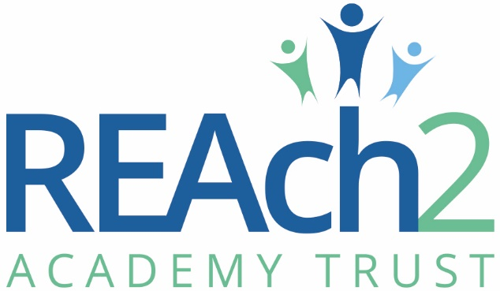

Local Governor application form
Our school is part of REAch2 Academy Trust, which was founded in 2012 and is now the largest primary-only academy trust in the country.

The Trust is a family that delivers school to school improvement, going the extra mile for all our children. We are passionate about dispelling the myth that only certain children are able to achieve. This is an opportunity to join a school which is part of a transformational trust that has taken its schools from 17% to 93% Ofsted ‘Good’ Academies (July 2023).

Our Touchstones
What gives each REAch2 Academy its uniqueness is the “touchstones” of the Trust: seven principles, which make our Academies distinctive. Just as 500 years ago, touchstones were used to test the quality of the gold they marked, so too our touchstones are used to express values and ethos of the Trust. They describe what the Trust wants to be known for and how it wishes to operate. REAch2 serves a wide range of communities across the country and we celebrate the economic, social, cultural and religious diversity that this brings: embracing inclusion ensures that we are a Trust that serves all, believing that everyone can and must succeed.
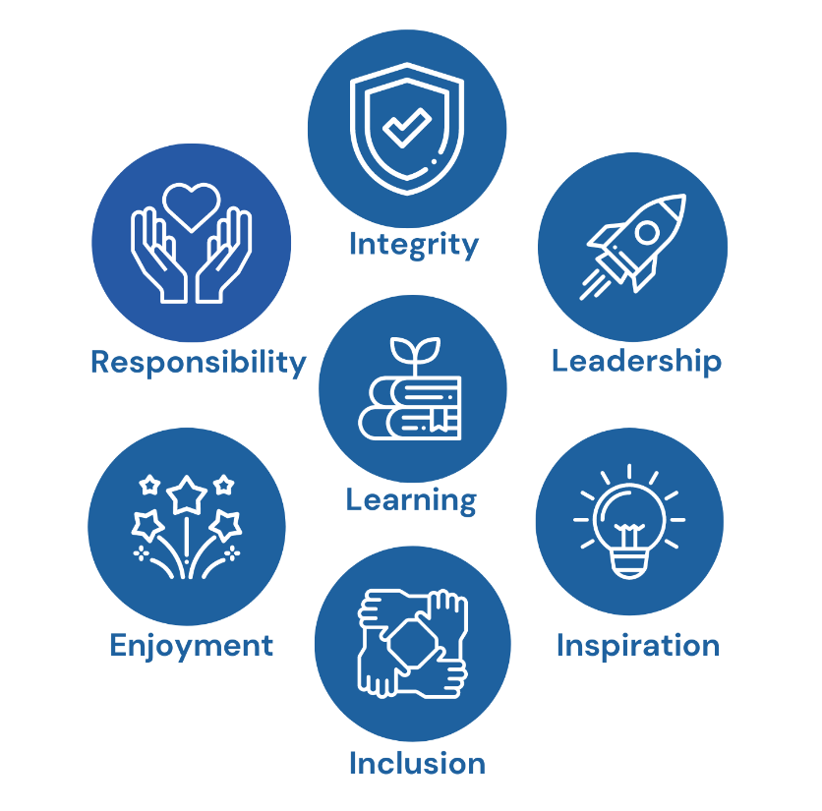
Data protection notice
Throughout this form we ask for some personal data about you. We will only use this data in line with data protection legislation and process your data for one or more of the following reasons permitted in law:
- You have given us your consent
- We must process it to comply with our legal obligations

You will find more information on how we use your personal data in our privacy notice for Trustees, governor and other volunteers.

Your personal data and application will be retained in line with REAch2 Information and Records Retention Policy, which can be found on the REAch2 website. We store volunteer information on our governance database at school level and this is also accessed by the Trust Central team to provide communications and support to you on an individual and Board basis.

Disclosure and barring and recruitment checks
Safeguarding is at the core of our work in REAch2. We carry out several checks before you can become a member of a governing body. Your position as a local governor will be conditional on the satisfactory completion of the necessary safer recruitment checks.

The Trust is legally obliged to process an enhanced Disclosure and Barring Service (DBS) check before making appointments to governor roles. The DBS check will reveal both spent and unspent convictions, cautions, reprimands and final warnings, and any other information held by local police that’s considered relevant to the role. Any information that is “protected” under the Rehabilitation of Offenders Act 1974 (Exceptions) Order 1975 will not appear on a DBS certificate.
The amendments to the Rehabilitation of Offenders Act 1974 (Exceptions) Order 1975 (2013 and 2020) provides that when applying for certain jobs and activities, certain convictions and cautions are considered ‘protected’. This means that they do not need to be disclosed to employers, and if they are disclosed, employers cannot take them into account.
Guidance about whether a conviction or caution should be disclosed can be found on the Ministry of Justice website. For further impartial advice, please visit – NACRO.
Any convictions listed on a DBS check and/or in the self-declaration form will be considered on a case-by-case basis.
Any data processed as part of the DBS check will be processed in accordance with data protection regulations and the trust’s privacy notice.

If you have lived or worked outside of the UK for a six month period in the last 10 years the trust may require additional information in order to comply with ‘safer recruitment’ requirements. If you answer ‘yes’ to the question below, we may contact you for additional information in due course.

Have you lived or worked outside of the UK for a six month period in the last 10 years?:
☐Yes ☐No

We will not ask for any criminal records information until we have received the results of a DBS check.
Any convictions listed on a DBS check will be considered on a case-by-case basis.

Applicants should be aware of the following circumstances which might prevent them from being appointed as a local governor:
- Inclusion in the list of those unsuitable to work with children
- Have been sentenced to 3 months or more in prison (without the option of a fine) in the 5 years before becoming a governor or since becoming a governor
- Have received a prison sentence of 2 ½ years or more in the 20 years before becoming a governor
- Have received a prison sentence of 5 years or more
- Have been fined for causing a nuisance or disturbance on school premises during the 5 years prior to or since appointment or election as a governor.

identity check
Documentation used for the enhanced DBS check will also be used to provide an ID check.

section 128 check
The school will carry out a section 128 check. A person issued with a section 128 direction under the Education and Skills Act 2008 is prohibited or restricted from taking part in the management of a school; this includes trustees and governors.

right to work in the uk and other checks
The school will carry out checks to confirm your right to work in the UK, and any other checks deemed necessary where you have lived or worked outside of the UK.

social media checks
In line with changes in statutory safer recruitment guidance in September 2022, we will carry out an online search of shortlisted candidates in order to identify any publicly available information that may indicate an issue or concern that needs to be followed up during interview. We require you to share with us as part of your application the account names, usernames and/or handles for any social media platform that you use, as well as the names of any websites that you own, post on, or contribute to. A Google search will also be conducted. These checks will only be conducted if you are shortlisted for interview. Please see our safer recruitment and selection policy for further information.
Facebook:  Twitter:  Instagram:  LinkedIn: | TikTok:  Reddit:  Pinterest:  Other (please list):

URLs for websites that you own, post on, or contribute to:

failure to supply documentation
Our commitment to safer recruitment helps us to safeguard our pupils and staff. We ask that DBS and identity checks be completed before your attendance at your first governor activity (meeting or visit) and must be completed within 21 days of appointment.
Failure to supply adequate documentation within the required deadline will result in removal from the local governing body with immediate effect.

Disclosure
If you feel that there are any issues which may arise as a result of one of these checks, please discuss it with the head teacher or you can contact a member of the Governance team to have an initial conversation at governance@reach2.org

more information about checks
We abide by the regulations as set out in the Academy Trust Handbook 2023 (Section 1.47) and the Governance Handbook (Section 4.1.2 para 16) to ensure that DBS and other checks are carried out.

References
Please provide one person to give a reference for you. They cannot be related to you but should be able to comment on your suitability to join our local governing body.
referee 1
Name
Relationship to applicant
Phone number
Email address

sign and date
Please sign and date below to confirm that you have understood the nature of and consent to the checks to be carried out.

Name (please print):
Sign:
Date:
Instructions
Please complete all sections of this form.

Applications will only be accepted if they are completed in full.

Completed applications should be returned to governance@reach2.org

Personal details and eligibility
Personal details
Title
Name
Address
Phone number
Email address

Eligibility
I confirm that I:
- Am aged over 18
- Have not been declared bankrupt
- Am not the subject of a bankruptcy restrictions order or an interim order
- Have not been disqualified from holding office as a governor
- Have not been disqualified from being a company director and/or a charity trustee
- Have not been removed as a trustee for a charity by an order made by the Charity Commission or the High Court on the grounds of misconduct or mismanagement in administration of the charity

Please sign and date to indicate that you have read, and agree to this information:

Signature: _____________________________________ Date: ____________________

About you…

REasons for becoming a governor
Which type of governor are you applying to become?
Trust-appointed governor | Co-opted governor | Parent governor | Staff governor
Cluster Board Non-Exec

Why would you like to become a local governor/cluster board non-exec? (if applying for parent of staff governor role, this statement will be used on the ballot paper if a vote is required)

What skills/experience can you bring to the role?

Please tell us about any previous experience you have as a governor/trustee/volunteer:

Please tell us if you have any connections with a member of staff, a pupil or a member of the LGB at our school:

Please tell us if you are currently serving as a governor at any other educational establishment:

I understand that, if I am standing for election as a parent or staff governor, then the responses to questions 1 and 2 will be used for election purposes.
Please tick to confirm your understanding of this:

