**Homework Menu - Old Bear**

**Choose three tasks to complete during this month.**

Create a dance routine using simple movements to represent being in a toy room.

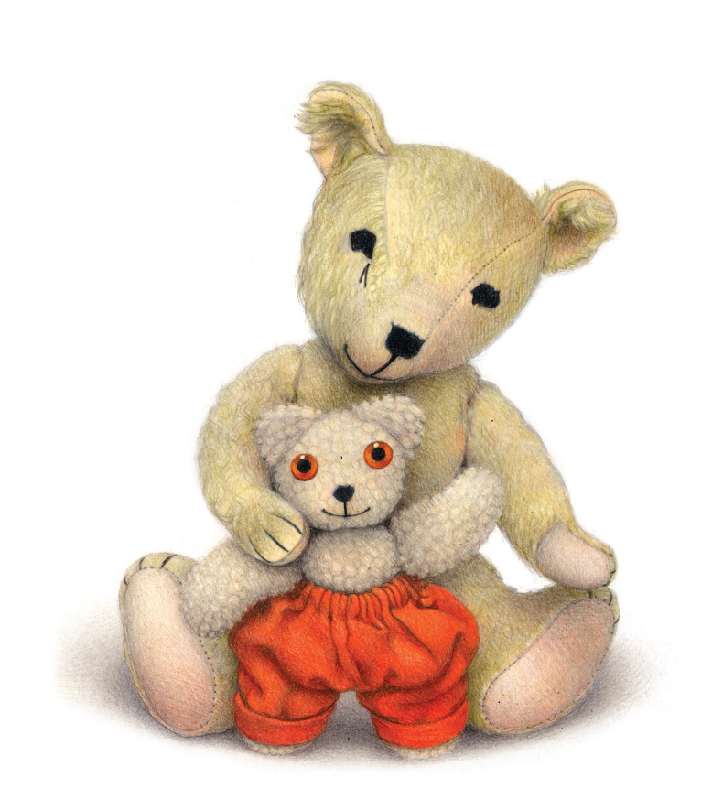

Listen to music from Scotland.

Have you seen this instrument before?

To practise their maths skills using online platforms

<https://play.numbots.com/>

https://whiteroseeducation.com/1-minute-maths

To pack a suitcase ready for a winter trip.

Draw a picture of something you did over the summer holidays. Use a range of media: crayons , paint, junk modelling.

Take photos or a vlog of your teddy bears morning routine.

(Brushing their teeth, eating breakfast).

To create a treasure map.

Don’t forget to use a key to show your landmarks.