**Year 1 – Autumn 2 Learning Overview**

**Writing:** Our focus book is Rapunzel. The key knowledge and skills we will be focusing on are:

* Correctly using capital letters and full stops
* Using the word ‘and’ to add more information
* Correctly using the -ed suffix
* Correctly using the -er suffix

We will have two writing outcomes for this term; traditional tale narrative and instruction writing.

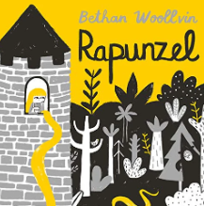

**Maths:** Our key focuses this half term is subtraction and geometry. We will be focusing on fact families and subtracting numbers within 10 on a number line or part whole model. Moving on, we will begin to name and describe a variety of 2D and 3D shapes. Ending with using the shapes to create patterns.

**RE:** Our key focus is ‘How might your religion or worldview be seen in the choices you make?’

**DT:** Our key focus is cooking and nutrition. We will be selecting and cutting vegetables to create a salad to meet a design brief. In this unit, we will describe fruits and vegetables by their basic characteristics and name the range of places that they grow.

**PE:** We will continue to develop our skills with our weekly Gymnastics and Dance lessons that we started last half term.

**History:** Our key focus is ‘How am I making History?’ We will be looking at timelines and correctly using the terms ‘before’ and ‘after’ when discussing them. We will move onto explaining why memories are important and naming events we celebrate throughout the year. Throughout the unit, we will use key vocabulary to compare the present, the past and the possible changes in the future.

**Science:** Our key focus is everyday materials. We will begin by naming objects and identifying the materials that they are made from before moving onto recognising that objects are made from materials that suit their purpose. We will end by recalling that a property is how a material can be described.

**Homework Menu – How am I making history?**

**Choose three tasks to complete during this half term.**

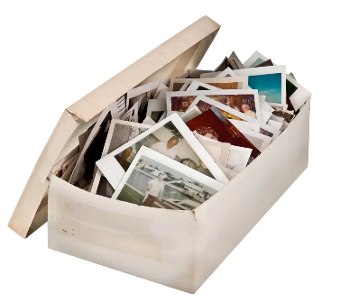

Can you create your own Traditional Tale. Think carefully about whether the character is good or bad. You might want to create your own Role on the Wall for your character.

What is your favourite vegetable or fruit? Can you research where it grows? Maybe you could create a plate using your favourite food!

Interview an older relative or friend to find out what childhood was like for them. You may want to film your interview or write the answers down.

Read a Traditional Tale. Can you spot the vocabulary that lets us know it is a Traditional Tale?

Can you create a simple Gymnastics routine to show Rapunzel escaping the tower?

Practice your Maths skills using <https://play.numbots.com/>

Login to Oxford Owl and complete your reading quiz for the week.