**Year 1 – Spring 1 Learning Overview**

**Writing:** Our focus book is Hermelin. The key knowledge and skills we will be focusing on are:

* Correctly using capital letters and full stops
* Using the word ‘and’ to add more information
* Correctly using the prefix -un
* Correctly using the suffix -est
* Using exclamation marks and question marks

We will have two writing outcomes for this term; detective narrative and letter writing.

**Maths:** Our key focuses this half term is addition and subtraction within 20 and Place Value to 50. We will be focusing on using the concreate resources taught in the Autumn Term to help us with these bigger numbers.

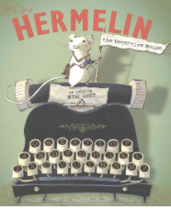

**RE:** Our key focus is ‘Where do people turn for guidance in life?’ We will begin to understand what Philosophy is and explore other non-religious groups.

**Art:** We will be working on a whole school project to celebrate the wonderful world around us. The focus will be on wildlife in a variety of different habitats and using these as inspiration to create works of art.

**PE:** We will be focusing on send and return as well as Hit, Catch Run. The children will be practising how to hit objects with a hand or bat as well as throw and catch a variety of balls and objects.

**Geography:** Our key focus is ‘What is it like here?’ The children will get another opportunity to work on their map skills this term. We will be locating our school on an ariel map before we create our own maps of the school grounds.

**Science:** Our key focus is sensitive bodies. The children will be identifying and naming parts of the body and conducting practical activities with the senses to spot patterns and answer questions.

**Homework Menu – What is it like here?**

Create your own landmark for your own city or town! Think about what media or materials you will use to create this.

Has something gone missing from your home? Can you write a missing poster for it to help you find where it might have gone?

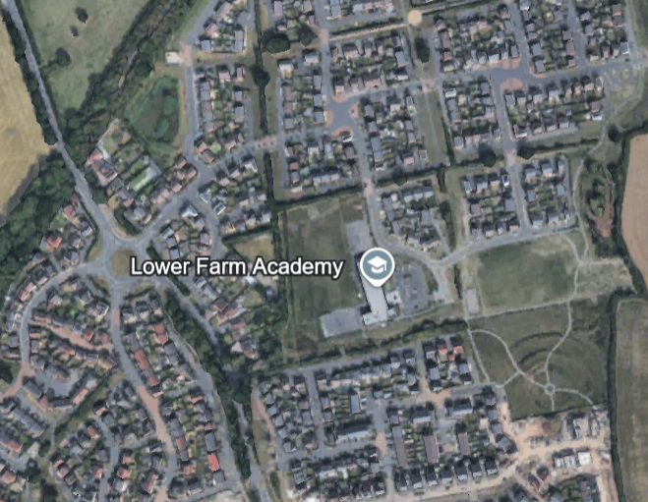

Choose a partner to play Simon Says. How many different parts of the body can you include in your game? Can you think of some obscure body parts that your partner will not know?

Create your own send and return game. What equipment will you use and why? What are the rules? Get creative!

Take a walk in your local area. When you get home can you draw a map of your route? What landmarks did you come across?

Practice your Maths skills using <https://play.numbots.com/>

Login to Oxford Owl and complete your reading quiz for the week.