

**Homework Menu – The Wild Things**

**Choose three tasks to complete during this term.**

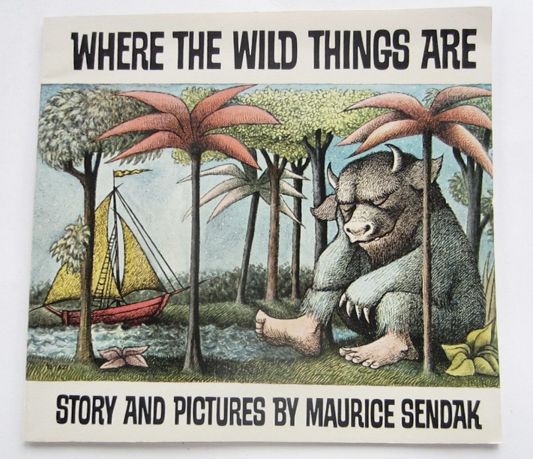

Draw two animals that are from different groups and compare the different features.

This could be a mammal and a fish.

Create your very own fact file on a mythical creature.

Spend time in nature and take some photos of what you have seen or activities you took part in.

Practise your sending skills by throwing a ball with another person or against a wall. Have a go at using under arm and over arm.

Interview an older relative or family friend on what toys they used to play with.

Create a puppet at home of one of our Wild Thing characters.

To practise their maths skills using online platforms

<https://play.numbots.com/>

https://whiteroseeducation.com/1-minute-maths